Sršen knows that an analysis of Bellabeat’s available consumer data would reveal more opportunities for growth. She has asked the marketing analytics team to focus on a Bellabeat product and analyze smart device usage data in order to gain insight into how people are already using their smart devices. Then, using this information, she would like high-level recommendations for how these trends can inform Bellabeat marketing strategy.

**Ask**

Sršen asks you to analyze smart device usage data in order to gain insight into how consumers use non-Bellabeat smart devices. She then wants you to select one Bellabeat product to apply these insights to in your presentation. These questions will guide your analysis.

1. What are some trends in smart device usage?

* Tech devices have ranked as one of the top 5 most-purchased gift categories each of the past two years. 61% of people own a smart device. Smart speakers, smartwatches, wireless headphones, and wireless speakers are among the top consumer electronic devices purchased on a mobile phone.Tech shoppers spend 74% of their time researching online versus 26% offline. 76% of people use some form of AI weekly. [Smart device use statistics - Think with Google](https://www.thinkwithgoogle.com/future-of-marketing/emerging-technology/smart-device-use-statistics/)
* Fitness trackers and Smartwatches are among the most popular wearables amongst people growing from 9% to 33% within the last few years. Quantilope ran a survey of 248 US wearable owners from the ages of 18-69, and 63% of them owned a fitness tracker or smart watch. [Wearable technology trends that will shape healthcare in 2022 (insiderintelligence.com)](https://www.insiderintelligence.com/insights/top-healthcare-wearable-technology-trends/)

[Quantilope](https://app.quantilope.com/share/eXse5utssLSMQTS8K?type=dashboard)

* Women spend more time searching on an app on their smartphone, and even more time on their tablet than men. Millennial womens purchasing power is growing, and they are more likely to spend money on high-cost items that have a good deal, positive customer reviews, and a brand's origin story along with its stance on social issues. [Millennial Women Have Strong Purchasing Power. What Influences It? - Marketing Charts](https://www.marketingcharts.com/demographics-and-audiences/women-demographics-and-audiences-82773) [Women Are Above-Average Users of Smartphones and Tablets - Marketing Charts](https://www.marketingcharts.com/demographics-and-audiences/women-demographics-and-audiences-107612)

2. How could these trends apply to Bellabeat customers?

These trends can apply to Bellabeats wearable health tracker Ivy and Leaf. With online purchases surging, electronics are normally a pricey item people are more than willing to buy especially if it improves daily quality of life. Headphones that fit over your ear so it's less likely to fall off when you're working out, or smaller ones so you can hide it behind your hair are ideas that influence people's decisions to buy certain products. With the 2020 pandemic, fitness being promoted on social media, and people becoming more aware of their health in general, smartwatches and fitness trackers have become very popular amongst the general public. They are especially more popular amongst women who are leading the growth of 96% in wearable sales. [Global wearable sales double YoY, women users lead the way - Futurum Research](https://futurumresearch.com/pew-the-size-of-the-wearables-market-has-doubled-since-last-year/#:~:text=According%20to%20the%20study%2C%2021,to%20attract%20more%20male%20shoppers.). With millennial women increasing purchasing power, and the growing market of wearables, Bellabeats Ivy has an opportunity of standing out amongst consumers.

3. How could these trends help influence Bellabeat marketing strategy?

These trends can help identify Bellabeats' audience of women, and where to promote it. Social networking sites such as Facebook, Instagram, and Pinterest are very popular amongst women and they spend the majority of their time on their electronic devices on these apps. Ivy’s elegant style can be used to its advantage with its abilities to analyze the body's vitals, and is relatable since it can also help track a woman's menstrual cycle. This can also increase Bellabeats brand and make women feel as if they have a company who understands them, by making sure they are in top condition as they live their story.

Task: Make recommendations to BellaBeats Marketing team to help them see how consumers use wearable technology.

**Prepare**

The data used will come from the Fitbit Fitness tracker data set from Kaggle. This data set was conducted through a survey of thirty three individuals who used the health tracker to measure their vital data. Things such as heart rate, sleep monitoring, and physical output were recorded in this exercise. Though this data is limited by varying factors such as gender, age, and lifestyle, it still covers a general perspective of what a health tracker gathers from individuals. [FitBit Fitness Tracker Data | Kaggle](https://www.kaggle.com/datasets/arashnic/fitbit)

For more information here's the link for the background of the study along with the licenses.

Furberg, Robert; Brinton, Julia; Keating, Michael ; Ortiz, Alexa

[**https://zenodo.org/record/53894#.YMoUpnVKiP9**](https://zenodo.org/record/53894#.YMoUpnVKiP9)

Furberg, R., Brinton, J., Keating, M., & Ortiz, A. (2016). Crowd-sourced Fitbit datasets 03.12.2016-05.12.2016 [Data set]. Zenodo. https://doi.org/10.5281/zenodo.53894

**Process**

SQL, and google sheets were chosen for this study, because their tools for sorting through data allowed me to analyze the data set at an optimal speed. I chose to use the **dailyactivity_ merged**, **weightloginfo_merged**, and **sleepday_merged**, datasets because they held the information that told the story of the participants. Your vitals such as heart rate and metabolism vary from person to person, and there could be more internal factors such as certain medical conditions, genetics, and handicaps determining what they are at that moment. Measuring the users sleep, weight, and daily activity required the participants activities to be recorded on a more relatable scale, and this helps determine what they mostly use the tracker for.

First I checked the data with google sheets and noticed that in the sleep day dataset, it had 3 duplicates that needed to be removed. The dataset also doesn't have an exact metric in the distance column, but after measuring the steps to the distance, I concluded that miles or kilometers was the metric that could be used. The weight log had a column labeled fat and I ended up deleting it because it had too many missing values creating a lot of whitespace. I didn't find any errors in regards to spelling, and the format for date and time needed to be changed to a custom format in order to be eligible to be analyzed with SQL.

I sent the data to SQL in order to take a deeper dive in making sure that everything was consistent, when I noticed that the number of participants varied by the dataset table.

Daily activity= 33, sleep day=24 weight log=8 user IDS. This let me know that everyone wasn't using the tracker for the same purpose, so I checked the IDs of everyone to make sure there weren't any outliers such as a missing number that could explain why the datasets had different counts of people. I also needed to make sure that these were the same participants, so I combined them and found that these were the same 33 participants from the beginning, and that the null values were just to show that they didn't use that feature.

**--Number of participants in study**

**Select Count (Distinct id)**

**From [SQL Prac].[dbo].[BellaBeat daily]**

**--Measured activity time**

**Select SUM(SedentaryMinutes) as [SM],**

**SUM(LightlyActiveMinutes) as [LA],**

**SUM(FairlyActiveMinutes) as [FA],**

**SUM(VeryActiveMinutes) as [VA]**

**FROM [BellaBeat daily]**

**--Measured activity distance**

**Select SUM(SedentaryActiveDistance) as SDis,**

**SUM(LightActiveDistance) as LDis,**

**SUM(ModeratelyActiveDistance) as FDis,**

**SUM(VeryActiveDistance) as VDis**

**From [BellaBeat daily]**

**--Number of Participants who used the weight features**

**Select COUNT (Distinct id)**

**From [BellaBeat data - weightLogInfo]**

**--Number of Participants Who used the sleep features**

**Select Count (Distinct id)**

**From [BellaBeat data - sleepDay (1)]**

**--Joined Tables to check matching ids between daily and weight**

**Select \***

**From [BellaBeat daily]**

**Full Outer Join [BellaBeat data - weightLogInfo]**

**On [BellaBeat daily].Id = [BellaBeat data - weightLogInfo].Id**

**--Joined Tables to check Matching ids between daily and sleep**

**Select \***

**From [BellaBeat daily]**

**Full Outer Join [BellaBeat data - sleepDay (1)]**

**On [BellaBeat daily].Id = [BellaBeat data - sleepDay (1)].Id**

**Analyze**

One of the main things I noticed was that the participants mostly used the trackers passively instead of actively. The tracker automatically measures your steps, scans your vitals, and tracks your movement throughout the day. They didn’t necessarily use it actively, or to its full potential such as was shown in the varying range of participants across the datasets. This makes me believe that people are more likely to purchase something based on how it is received publicly and looks rather than it actually being the superior product. You absolutely need a high quality product in order to compete with other businesses, but people choose sides based on brands similar to IPhone vs Android. Both Apple and Samsung are apex electronic companies with phones that have twin attributes just a different design, and consumers make it a war to the point of picking a team based on what they like, not what actually serves them. I believe that BellaBeat can become the top brand and make people more aware of its high quality products. Now, the reason that people are not using the tracker to its full potential doesn't come from them not wanting to, but from the fact they don’t realize its full capabilities. BellaBeat needs to bridge the gap between general use and women knowing the other features of Ivy or Leaf, that can help them in their daily life. This can help BellaBeat become the main brand that is known to represent women, and their products a common item most women have.

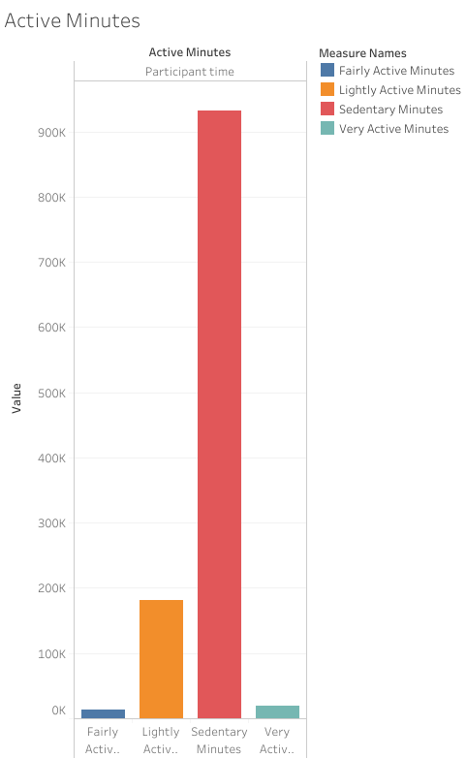

This graph is meant to show that the participants wearing the tracker mostly were stationary when wearing the FitBit. Sedentary is the least beneficial of the 4 categories to a participants fitness journey and won’t build their actual interest in the tracker.([What Is Your Activity Level and How Does It Impact Your Health? – ZOZOFIT](https://zozofit.com/blogs/news/what-is-your-activity-level-and-how-does-it-impact-your-health)) Their lifestyle has them mostly sitting down throughout the day, so with them having less combined active minutes than sedentary, one can conclude that the device is just on their wrist as an accessory, not something they’re making true use of. How often do they even look at the tracker, because social media and specific apps is what encourages high device usage? BellaBeat has an opportunity to encourage engagement in this area by making sure the public know that the Ivy and Leaf are more than just a fashion statement, but something meant to benefit your life.

**Visualize**

I wanted to show the correlation in my findings that even though the tracker was used, people didn’t truly understand it. The bar graph will show the activity that the fitbit tracked, and the pie chart will show how many of the participants actually explored the fitbit enough to try and log their own activities.

**Daily Steps**  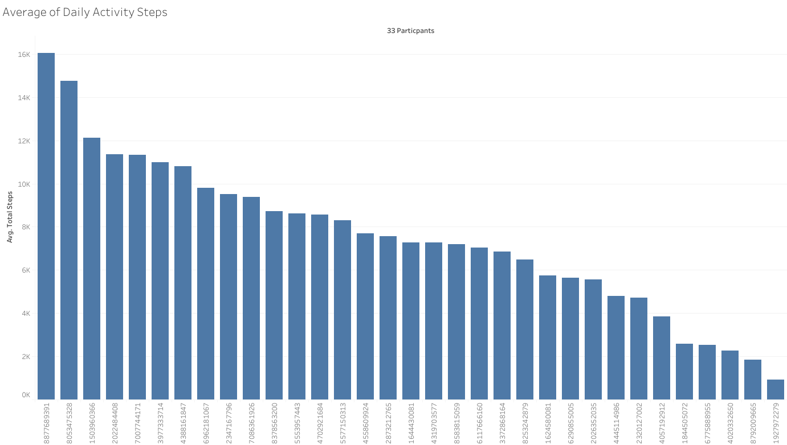

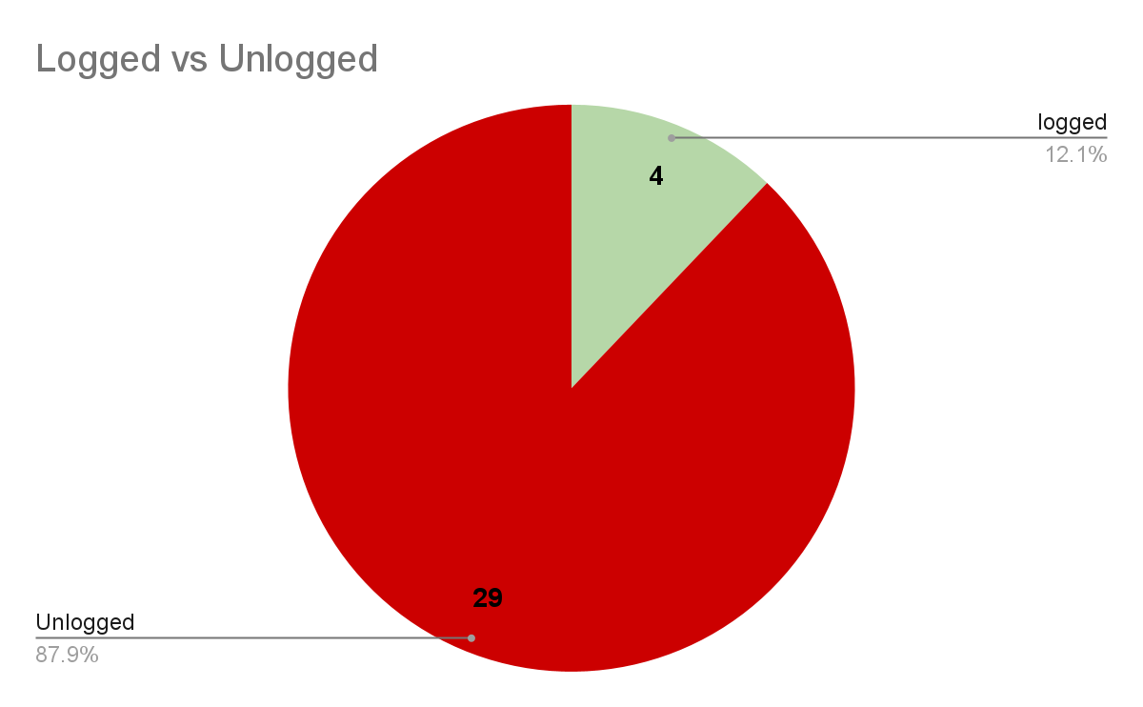

Even though all 33 participants were tracked, only 4 of them actually tried to engage with the fitbit to get more out of their daily steps. The Fitbit is automatic, but whenever they have it off for a duration of time such as to take a shower and beyond, they have no interest in trying to help the device log the information that it wasn't in position to receive. This means the participants are less likely to explore the fitbits capabilities, and are missing out on other features that could help them on their exercise journey.

**Weight log** 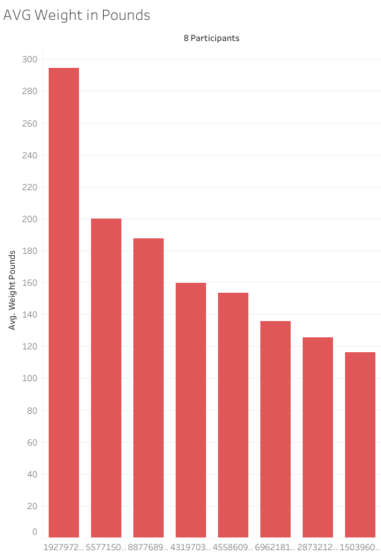

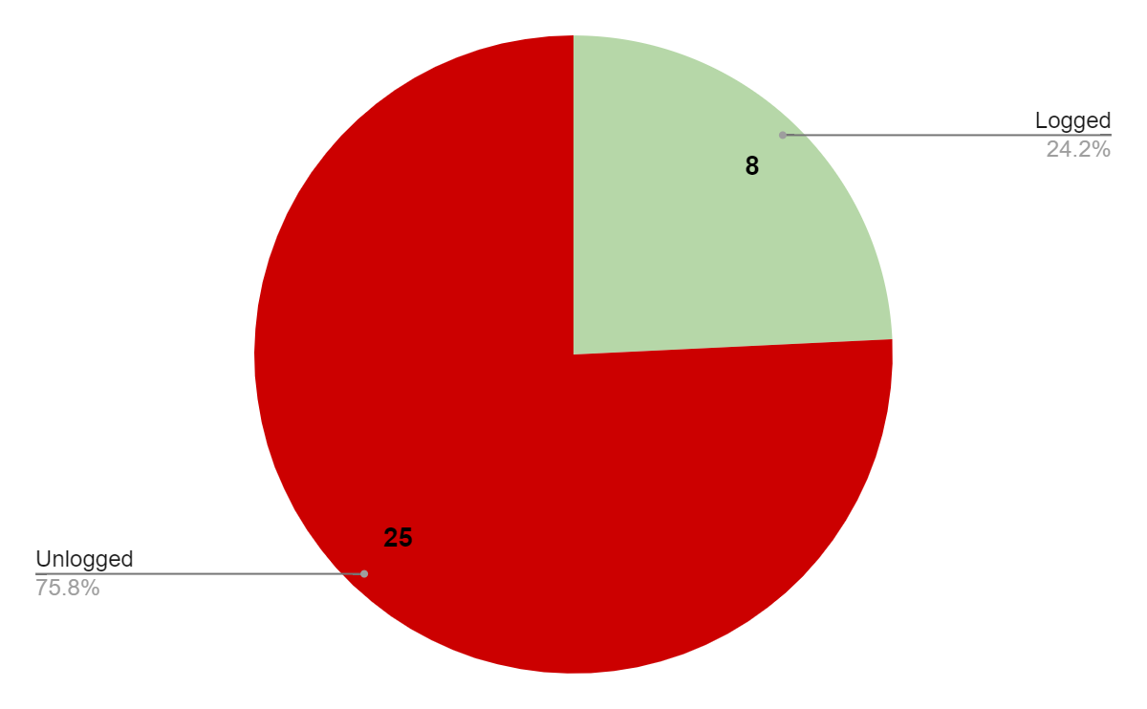

When it comes to the weight, only 8 out of the 33 participants actually logged their weight. This can impact results by making the wearers miss their goals such as drinking less water than what their body requires to lose weight. Even certain manual weight loss features such as exercise, calorie intake, and body composition are probably completely unknown to the consumer.

**Sleep Record**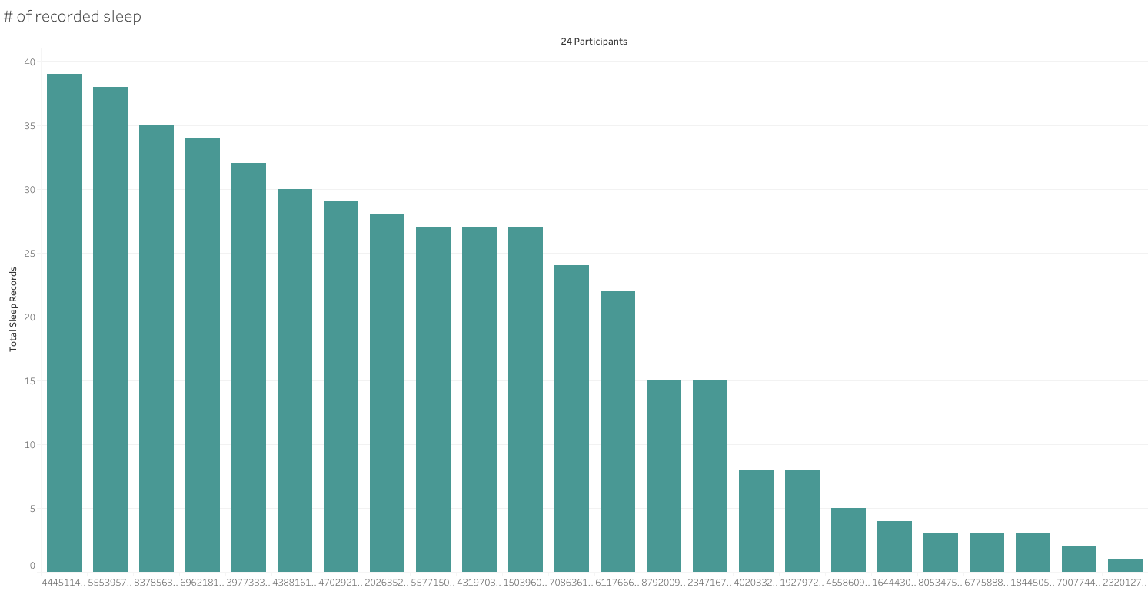

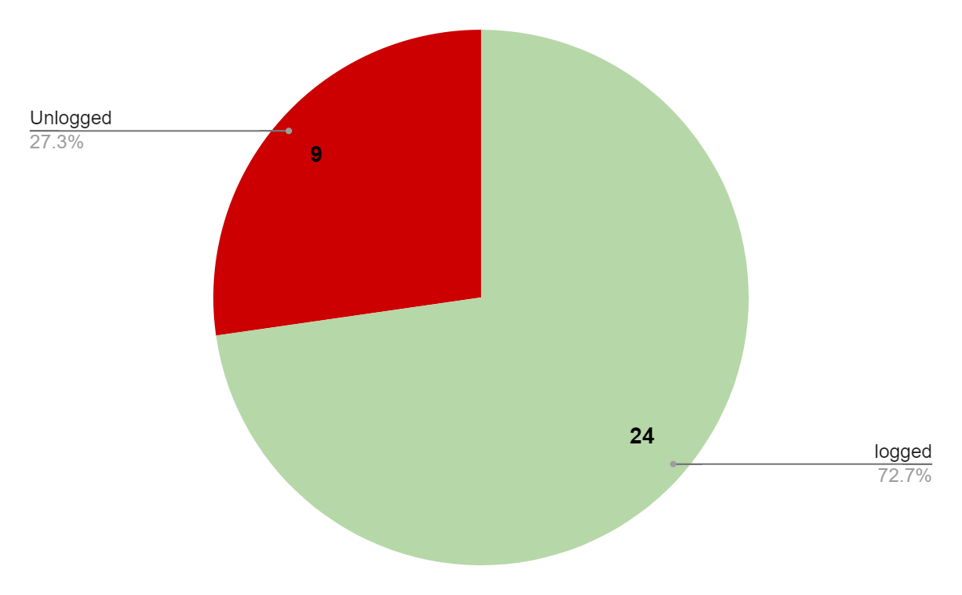

This was a more positive outcome because it shows that more than half set their tracker to monitor their sleep. Granted they only needed to sleep with it on, the fact that they did speaks volumes. What about this feature encouraged a 72% usage vs the others that couldn’t even get to 30%? The accessibility of the feature is important, because it may be alot easier to get to and simpler to use.

**ACT**

My suggestion would be to make BelaBeats Leaf and Ivy easy and simple to use in order to increase the likelihood of users exploring the features of the wearable more. Most people have a short attention span, so the user turning on a feature easily could encourage them to see other functions before they move on to something else.

A marketing campaign to increase brand awareness would also keep BellaBeat in the minds of its targeted audience.

We are in an era where mental health is being focused on more than ever before, and an exercise journey can be a daunting one. BellaBeat should become more hands on with engaging with its consumers, such as weekly videos, daily tips, encouraging quotes, and promoting its female exclusive features. With the increase in handheld technology such as phones and tablets, BellaBeat using their app for these purposes can create an opening for engagement with its audience.

Bella Beats menstrual cycle tracker, diary, and readiness score brings the relatable feel of having a big sister to help guide women through life. The marketing team could lead with these three in forming a connection with women in order to pull them away from the competition.

[Bellabeat’s Ivy bracelet tries to do it all — but it can only do some | TechCrunch](https://techcrunch.com/2021/11/12/bellabeat-ivy-bracelet-health-tracker-review/)